**Proposal for**

SUMMER UNDERGRADUATE RESEARCH AWARD (SURA) – 2013

Design and Fabrication of Interactive Autonomous Robot as a Research Platform: Robomuse3.0



**Rishabh Agarwal Durgesh Hathiyani**

Dept. of Mechanical Eng. Dept. of Mechanical Eng.

2012ME10710 2012ME10661

Contact No: 08377893886 Contact No: 09910921306

CGPA: 8.079 CGPA: 7.95

**FACILITATOR**

  Prof. Subir Kumar Saha

Professor   
Department of Mechanical Engineering   
Indian Institute of Technology Delhi

**INTRODUCTION**

Robomuse will be a line following industrial robot capable of handling few kilos of load and place it at a desired location without any human interference. An industrial robot is defined as an automatically controlled, reprogrammable, multipurpose manipulator programmable in three or more axes. Typical applications of robots include welding, painting, assembly, pick and place (such as packaging, palletizing and SMT), product inspection, and testing; all accomplished with high endurance, speed, and precision.

Robots exhibit varying degrees of autonomy:

1. Some robots are programmed to faithfully carry out specific actions over and over again (repetitive actions) without variation and with a high degree of accuracy. These actions are determined by programmed routines that specify the direction, acceleration, velocity, deceleration, and distance of a series of coordinated motions.
2. Other robots are much more flexible as to the orientation of the object on which they are operating or even the task that has to be performed on the object itself, which the robot may even need to identify. For example, for more precise guidance, robots often contain machine vision sub-systems acting as their "eyes", linked to powerful computers or controllers. Artificial intelligence, or what passes for it, is becoming an increasingly important factor in the modern industrial robot.

So basically the robomuse is an industrial robot which will pick and place some objects following a certain path with a high degree of accuracy. It will be on a permanent display in SAC, so that anyone can operate it by following a certain set of instructions and the robot will perform a particular task every time and without any human interference in its function.

**OBJECTIVE**

* Develop a 24x7 operational, autonomous mobile robot for industrial use (ROBOMUSE 3.0)
* Study of previous development in this direction at IIT Delhi
* Eliminate problems existing in previous design of ROBOMUSE
* Make a detailed CAD model of improved version ROBOMUSE 3.0
* Dynamic simulation of robot using RecurDyn
* Benchmarking with contemporary mobile robots in market
* Fabricate mechanical structure of robot
* Achieve 90% reliability and low maintenance

**APPROACH**

* The initial part of the project will be designing various mechanisms and complete body of the robot with the help of CAD modelling software and its complete force analysis.
* Next part includes manufacturing and fabrication of individual mechanisms and chassis.
* Then we will assemble all the various mechanisms with chassis and motors.
* Next section includes installation and calibration of various sensors like IR sensors   
  (for line following), proximity sensor (for object detection) and different drivers e.g. Sabertooth (for motor control) etc.
* Automation using micro controllers like Arduino (using c++ programing) will be our next step.
* After complete automation and fabrication of the robot we will focus on failure analysis and correction like both mechanical and electrical iterations, to ensure its industrial use and reliability.
* Finally we will install it in SAC.

**Work done till now:**

As a part of B.tech Project, Vishal Mehta (2010ME10693) and Gaurav Kumar (2010ME10673) completed the chassis of the robot and planned to add the gripper mechanism and charging mechanism till the end of the semester. Some of the pictures of the current robot are given below.

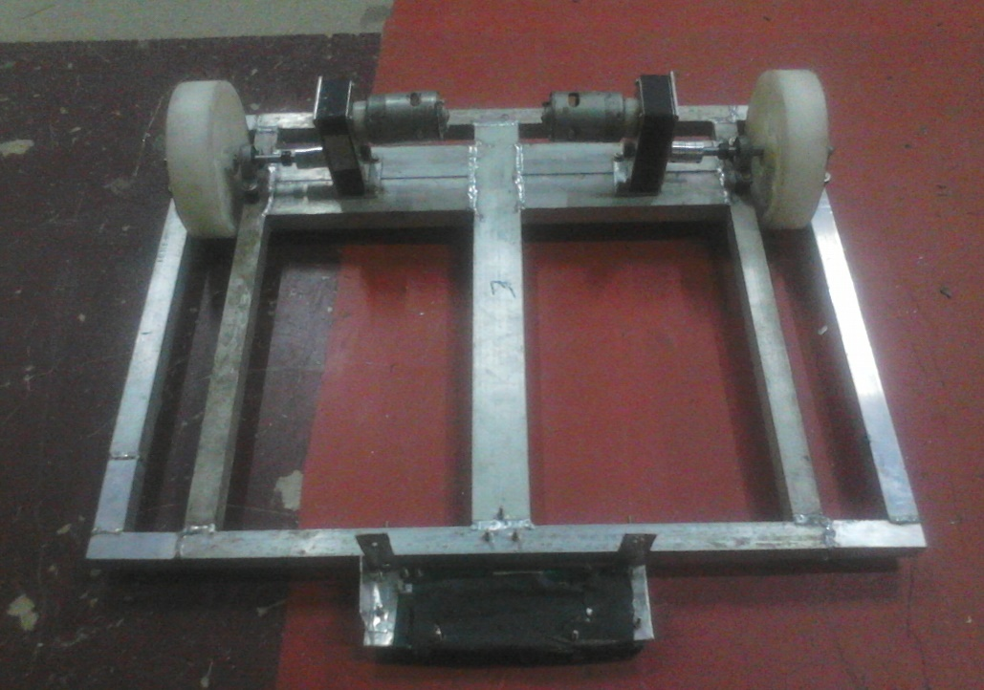

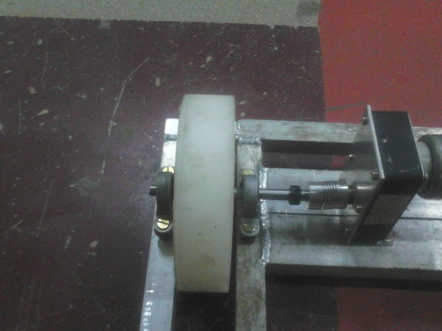

*Both the images are from B.tech presentation of Vishal Mehta (2010ME10693)

In the present edition of the robot we will add its path following and object detection feature with the help of IR sensors and proximity sensors.

We will also perform detailed testing based on ISO for e.g. ISO 9283: Manipulating industrial robots -- Performance criteria and related test methods, ISO 9946: Manipulating industrial robots -- Presentation of characteristics and ISO 14539: Manipulating industrial robots -- Object handling with grasp-type grippers**.**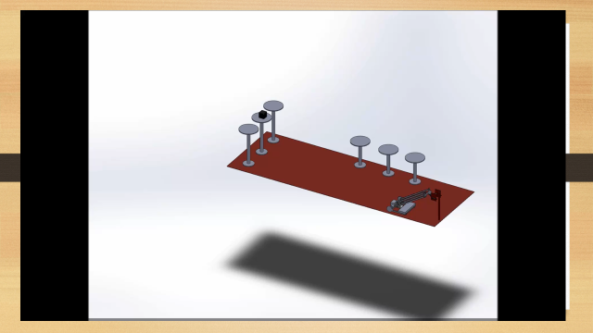

*CAD model of the field

**APPLICATION**

These types of robots are very essential in the industries where picking and placing of objects is required. Pick and place type of tasks include transfer of the objects from one assembly line to other (as in automobile industries), packing of products. A robot for this task reduces cycle time thus increasing production rates, also reduces chances of errors, and reduces human interference in the process. These pick and place robots are more accurate and do not fatigue while doing back-breaking or hard to maneuver movements that may be difficult for humans. An increase in output with a pick and place robot system offer long-term savings to companies. With the advancements in technology and affordability of robots, more pick and place robotic cells are being installed for automation applications. Pick and place robots can be manipulated easily to perform multiple applications. They just need to be re-programmed and tooled appropriately. This makes it possible for production unit managers and owners to accomplish myriad assembling tasks with one robotic system. From enabling businesses to produce on a large-scale to streamlining the work process and from increasing productive capacity to making the production line more efficient, these systems ultimately bring in riches for a business, both in terms of expanding business possibilities and increasing customer satisfaction.

**DURATION**

|  |  |  |  |  |  |  |  |  |
| --- | --- | --- | --- | --- | --- | --- | --- | --- |
| **Week** | 1 | 2 | 3 | 4 | 5 | 6 | 7 | 8 |
|  |  | | |  | |  | | |
|  | **Designing and manufacturing of a robust mechanical structure of the robot** | | | **Completing the electrical circuits of the robot** | | **Mechanical and electrical iterations** | | **Final installation** |

**BUDGET**

Mechanical Manufacturing: Rs 6000

Electrical devices: Rs 15000

Miscellaneous: Rs 4000

Total: Rs 28000

**FACILITIES REQUIRED**

Accelerometer and proximity sensor from vibration lab or design lab

Access to labs of mechanical, electrical and electronics department

Access to CAD modeling (solidworks) and Recurdyn software.

**REFERENCES**

[1] http://roboticsclub.iitd.ac.in/robomuse.html

[2] http://en.wikipedia.org/wiki/Industrial_robot

[3] http://www.robots.com/applications/pick-and-place

[4] http://www.bastiansolutions.com/robotics/robotic-solutions/pick-and-place-robotics

[5] http://www.iso.org/iso/iso_catalogue/catalogue_tc/catalogue_tc_browse.htm?commid=54138

[6] http://www.iso.org/iso/home/store/catalogue_tc/catalogue_detail.htm?csnumber=22244